To back up disk image of Rpi sdcard (boot OS)
Insert sdcard into a USB sdcard adapter
Use Win32DiskImager, choose H:\ device (make it the drive letter with sdcard)
Choose the storage location and image name in the Image File box
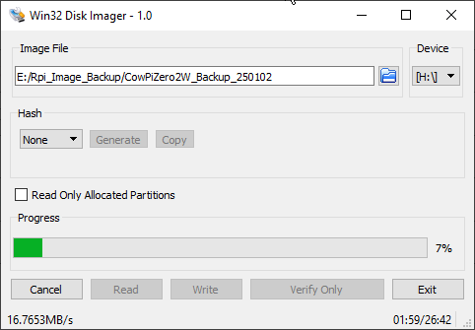
Click “Read” to read the image from the sdcard
It takes around 26 minutes to read the contents for a slower sdcard in USB adapter

To restore this image to a new sdcard for Rpi
Insert sdcard into a USB sdcard adapter
Use Raspberry Pi Imager
Choose the correct device (Rpi Zero 2W)
Scroll down to Custom for image to use, select the .IMG file created using Win32DiskImager above
Select the H:\ device (make it the drive letter with sdcard)

Running Rpi for first time after inserting new sdcard
Turn on hotspot, let it connect to network, find IP, use Terminal to ssh
Actually, it took a little while but it was already running rpi-connect and signed in…might need to power it on/off more than once and just be patient while watching the hotspot to make sure it connects.

